

|  |
| --- |
| **SUMMER COURSE**  **TIME SERIES DATA ANALYSIS** |
| **GROUP ASSIGNMENT** |

# Question 1

Table 1 shows the number of computers by a factory during the morning, afternoon and evening shifts of the week.

Table 1

|  |  |  |  |
| --- | --- | --- | --- |
| **Day** | **Morning** | **Afternoon** | **Evening** |
| Monday | 255 | 224 | 241 |
| Tuesday | 234 | 233 | 250 |
| Wednesday | 237 | 227 | 256 |
| Thursday | 240 | 239 | 259 |
| Friday | 240 | 230 | 256 |

1. Calculate the trend using the moving average method.
2. Draw the time series and the trend on the same graph.
3. Calculate the seasonal index for every shift. Interpret what you understand based on the result (You can use the given table to answer).

a)

|  |  |  |  |  |
| --- | --- | --- | --- | --- |
| Day | Quarter | Number of computer (Y) | Trend (T) | Variation (Y  T) |
| M | 1 | 255 | - | - |
|  | 2 | 224 | 240 | 0,9333 |
|  | 3 | 241 | 233 | 1,0343 |
| T | 1 | 234 | 236 | 0,9915 |

|  |  |  |  |  |
| --- | --- | --- | --- | --- |
|  | 2 | 233 | 239 | 0,9749 |
|  | 3 | 250 | 240 | 1,0417 |
| W | 1 | 237 | 238 | 0.9958 |
|  | 2 | 227 | 240 | 0,9458 |
|  | 3 | 256 | 241 | 1,0622 |
| TH | 1 | 240 | 245 | 0,9796 |
|  | 2 | 239 | 246 | 0,9715 |
|  | 3 | 259 | 246 | 1,0528 |
| F | 1 | 240 | 243 | 0,9877 |
|  | 2 | 230 | 242 | 0,9504 |
|  | 3 | 256 | - | - |

b)

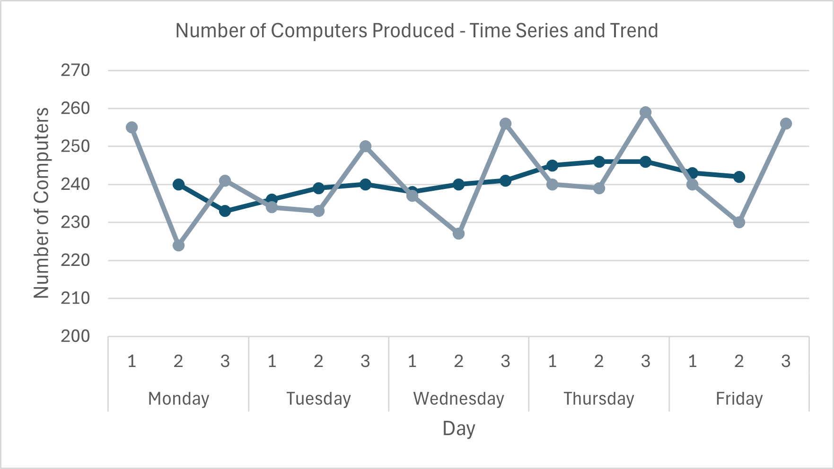

c)

|  |  |  |  |  |
| --- | --- | --- | --- | --- |
| Days | Q1 | Q2 | Q3 |  |
| Monday | - | 0,9333 | 1,0343 |  |
| Tuesday | 0,9915 | 0,9749 | 1,0417 |  |
| Wednesday | 0,9958 | 0,9458 | 1,0622 |  |
| Thursday | 0,9796 | 0,9715 | 1,0528 |  |
| Friday | 0,9877 | 0,9504 |  |  |
| Mean | 0,9886 | 0,9552 | 1,0478 | 2,9916 |
| CF | 1,0028 | | |  |
| SF | 0,9914 | 0,9579 | 1,0507 |  |
| SI | 99,14% | 95,79% | 105,07% |  |
| Interpret | Decrease | Decrease | Increase |  |

# Question 2

Table 2 shows the distribution number of cars sold by a 2nd hand car dealer Company ABC in for 2022-2024.

Table 2

|  |  |  |  |  |
| --- | --- | --- | --- | --- |
| **Year** | **Number Of Cars Sold** | | | |
| **Quarter 1** | **Quarter 2** | **Quarter 3** | **Quarter 4** |
| 2022 | - | - | 12 | 10 |
| 2023 | 12 | 10 | 13 | 13 |
| 2024 | 20 | 18 | - | - |

1. Find the trend values using moving average method.
2. Plot the time series data and the trend line on the same graph.
3. Calculate the seasonal indices for the four quarters and interpret the results.
4. Forecast the number of cars sold for the 2nd quarter of 2025.

ANSWER.

a)

|  |  |  |  |  |  |
| --- | --- | --- | --- | --- | --- |
| Year | Quarter | Number of Cars Sold | Centered of 4QtrMA | Trend = Centered of 2QtrMA | Variation |
| 2022 | 1 |  |  |  |  |
|  |  |  |  |  |  |
|  | 2 |  |  |  |  |
|  |  |  |  |  |  |
|  | 3 | 12 |  |  |  |
|  |  |  |  |  |  |
|  | 4 | 10 |  |  |  |
|  |  |  | 11,000 |  |  |
| 2023 | 1 | 12 |  | 11,125 | 0.927 |
|  |  |  | 11,250 |  |  |
|  | 2 | 10 |  | 11,625 | 1,163 |
|  |  |  | 12,000 |  |  |
|  | 3 | 13 |  | 13,000 | 1,000 |
|  |  |  | 14,000 |  |  |
|  | 4 | 13 |  | 15,000 | 1,154 |
|  |  |  | 16,000 |  |  |
| 2024 | 1 | 20 |  |  |  |
|  |  |  |  |  |  |
|  | 2 | 18 |  |  |  |
|  |  |  |  |  |  |
|  | 3 |  |  |  |  |
|  |  |  |  |  |  |
|  | 4 |  |  |  |  |

b)

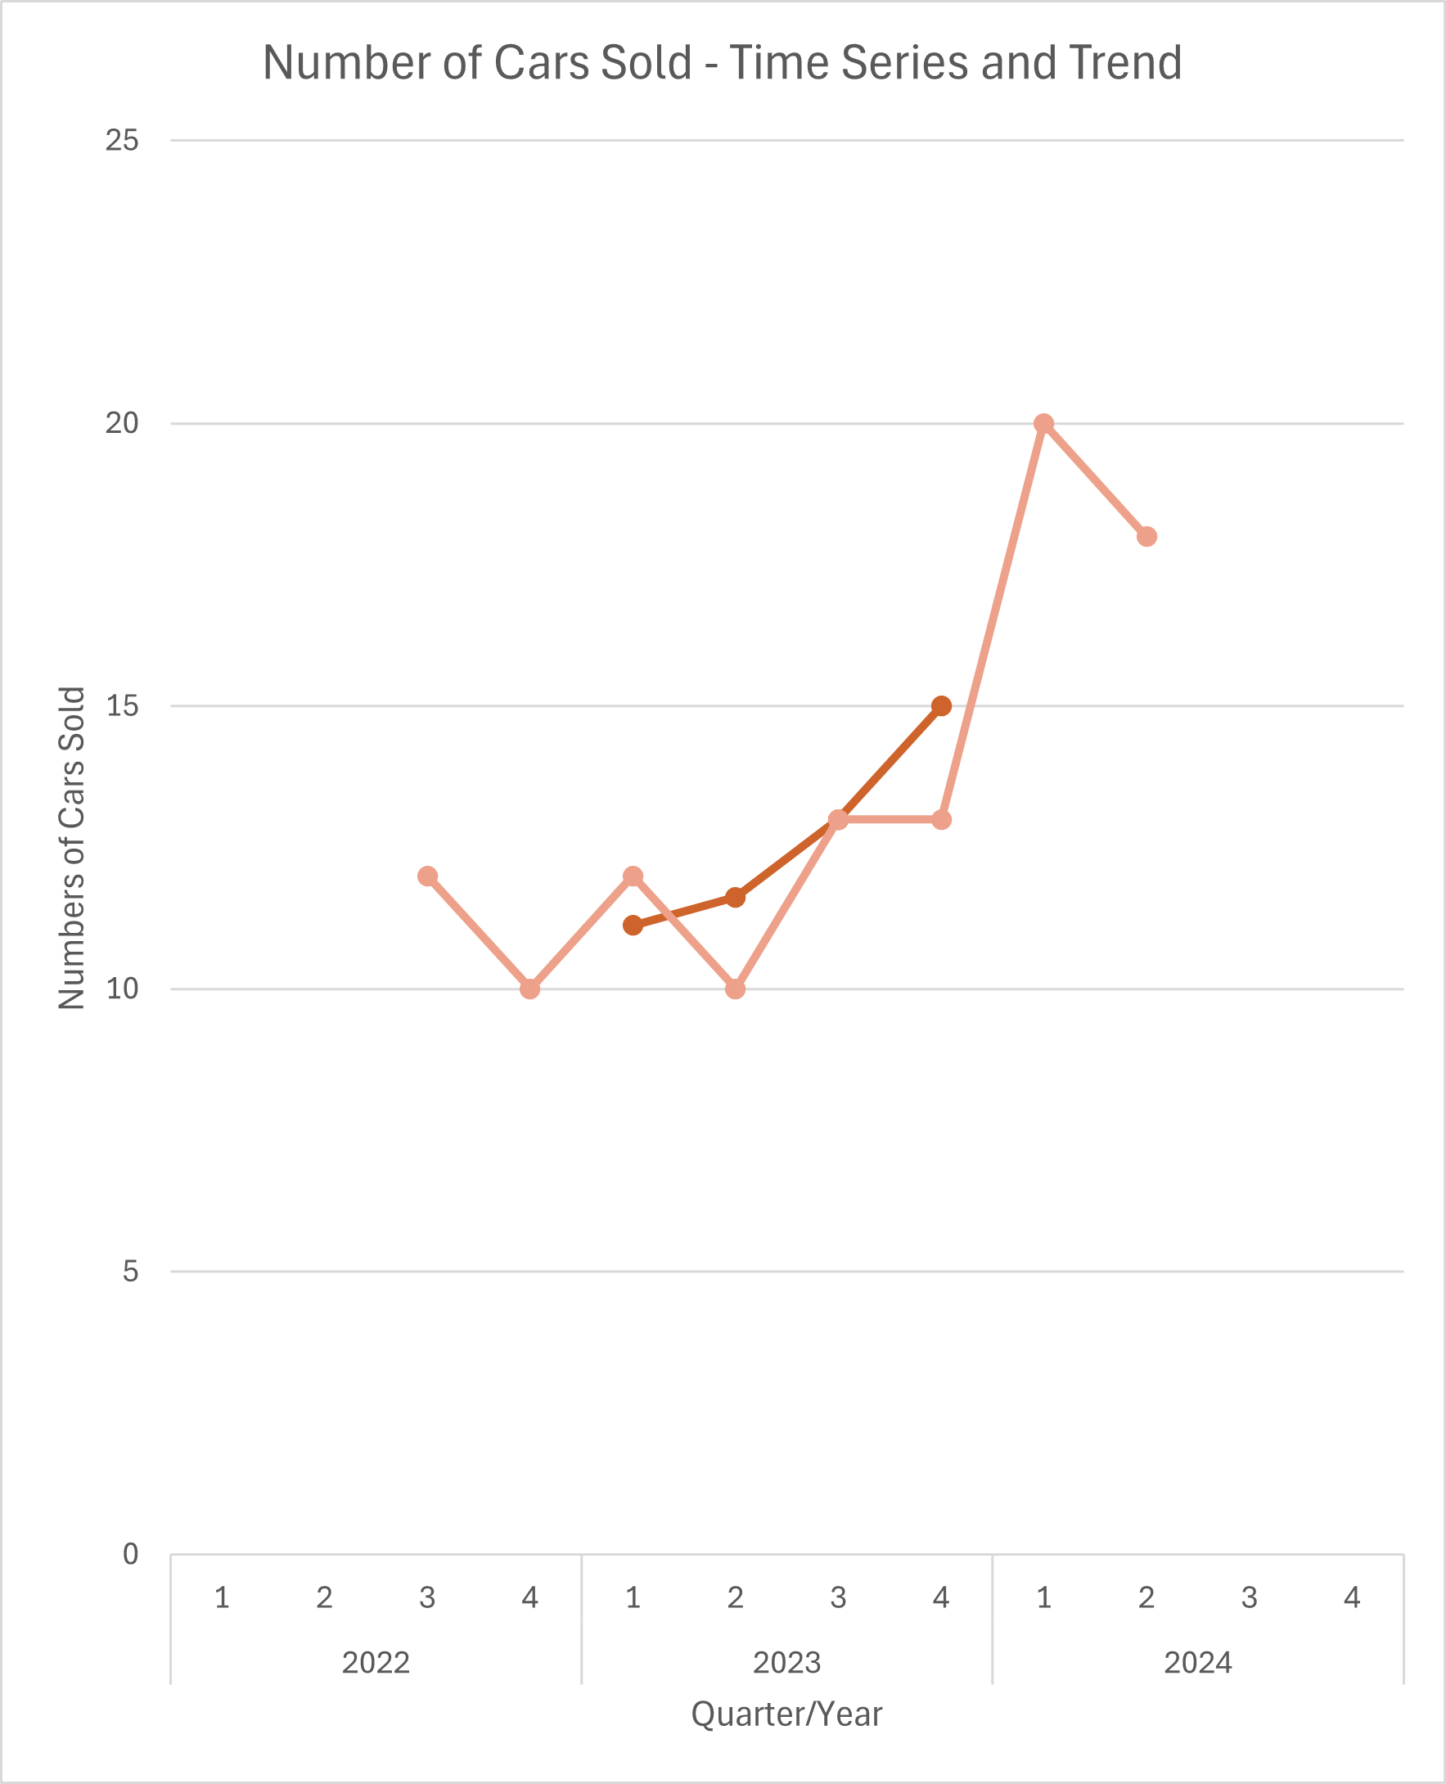

c)

|  |  |  |  |  |  |
| --- | --- | --- | --- | --- | --- |
| Year | Q1 | Q2 | Q3 | Q4 |  |
| 2022 |  |  |  |  |  |
| 2023 | 0,927 | 1,163 | 1,000 | 1,154 |  |
| 2024 |  |  |  |  |  |
| Mean | 0,927 | 1,163 | 1,000 | 1,154 | 4,243 |
| CF | 0,943 | | | |  |
| SF | 0,874 | 1,096 | 0,943 | 1,088 |  |
| SI | 87,39% | 109,58% | 94,26% | 108,77% |  |
| Interpret | Decrease | Increase | Decrease | Increase |  |

d)

a = 15,000

b = 1,292

|  |  |  |  |  |  |
| --- | --- | --- | --- | --- | --- |
| Year | Q | x | a+bx | SF | (a+bx)xSF |
| 2025 | 1 | 5 | 21,458 | 0,874 | 18,752 |
|  | 2 | 6 | 22,750 | 1,096 | 24,930 |
|  | 3 | 7 | 24,042 | 0,943 | 22,662 |
|  | 4 | 8 | 25,333 | 1,088 | 27,554 |

**ALL THE BEST!!!**